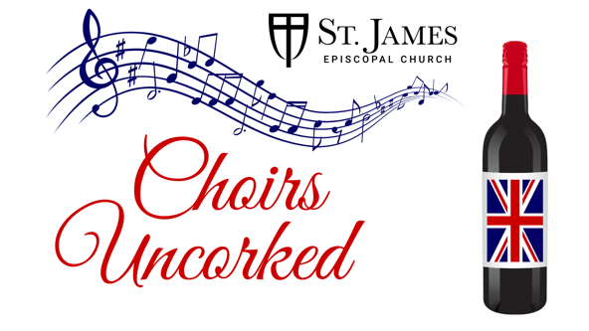
Choirs Uncorked Sponsorship Commitment Form
Please select your desired sponsorship level:
- Archangel Level - $10,000
  - 2 Tables of 8 with signage and prominent seating
  - Top logo placement displayed at the event and in music publications during the 2024/2025 season
- Cathedral Level - $5,000
  - Table of 8 with signage
  - Logos prominently displayed at the event and in music publications during the 2024/2025 season
- St. James Level - $2,500
  - Table of 8 with signage
  - Logos prominently displayed at the event and in music publications during the 2024/2025 season
- St. Cecilia Level - $1,000
  - Table of 8 with signage
  - Logos displayed at the event and in music publications during the 2024/2025 season
- St. Francis Level - $500
  - Name listed at the event and 2 complimentary tickets
Organization Name or Name of Individual
Name of Contact Person
Address
Phone
Email

Please return this form and logo (if applicable) to Shannon Gallier, sgallier@stjamesbr.org.
Please check your preferred payment method:
- Check (payable to St. James Episcopal Church)
- Please invoice me
- Contact Credit Card
Thank you for supporting Choirs Uncorked and the
St. James Episcopal Church Choir’s 2025 Choral Residency at Worcester Cathedral!

